2303A51581
BATCH-10
LAB ASSIGNMENT-4.3
Task 1: Zero-Shot Prompting – Leap Year Check
PROMPT
Generate a Python function that accepts a year as input, checks whether the given year is a leap year, and returns an appropriate result. Do not include any input-output examples in the prompt.
#Code
def is_leap_year(year: int) -> bool:
"""
Check if a given year is a leap year.

Args:
year (int): The year to check.
Returns:
bool: True if the year is a leap year, False otherwise.
"""
if (year % 4 == 0 and year % 100 != 0) or (year % 400 == 0):
return True
else:
return False
# User input
year_input = int(input("Enter a year to check if it's a leap year: "))
if is_leap_year(year_input):
print(f"{year_input} is a leap year.")
else:
print(f"{year_input} is not a leap year.")
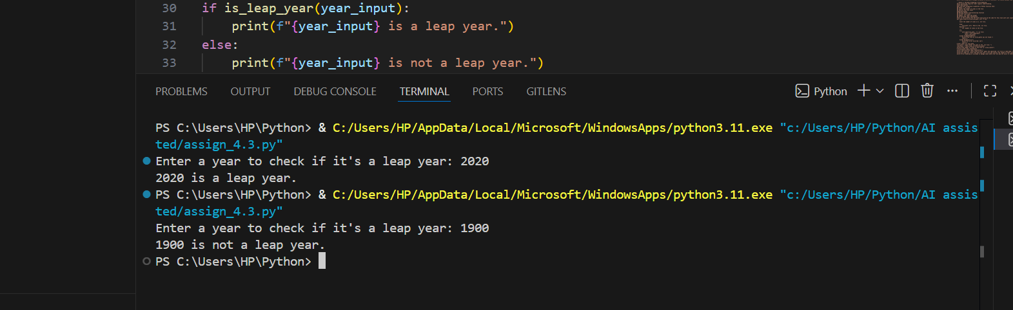
#Output
Analysis
Zero-shot prompting (no examples) creates a leap year function using only instructions. The code is correct, readable, and applies the right rules, but without examples the AI relies only on the description, making it less guided than one-shot or few-shot prompting.

Task 2: One-Shot Prompting – Centimeters to Inches Conversion.
#PROMPT
“Generate a Python function that converts centimeters to inches using the correct mathematical formula. Provide one input-output example to guide the task: Input: 10 cm → Output: 3.94 inches. The function should include accurate calculation and sample test cases with outputs.”
#Code
def cm_to_inches(cm: float) -> float:
"""
Convert centimeters to inches.

Args:
cm (float): Length in centimeters.
Returns:
float: Length in inches.
"""
inches = cm / 2.54
return round(inches, 2)
# User input
cm_input = float(input("Enter length in centimeters: "))
inches_output = cm_to_inches(cm_input)
print(f"{cm_input} cm is equal to {inches_output} inches.")
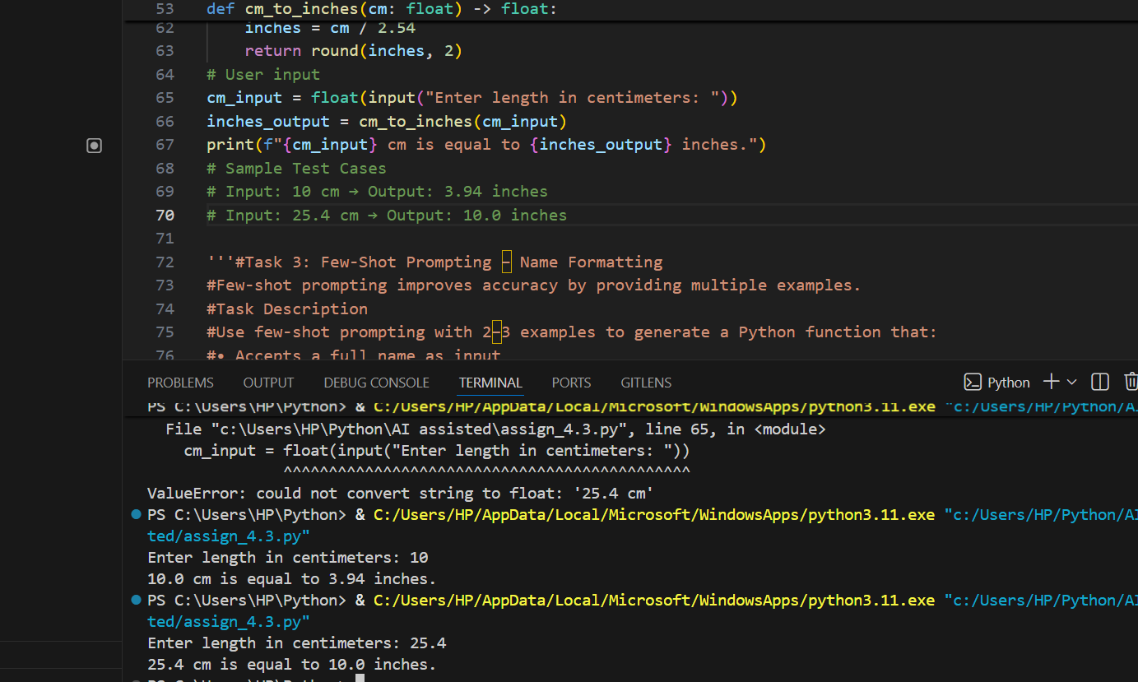
#Output

Analysis
One-shot prompting with a single example helps the AI apply the right formula for converting centimeters to inches. The function is simple, accurate, and easy to read, and test cases confirm it works correctly.
Task 3: Few-Shot Prompting – Name Formatting
#PROMPT
Generate a Python function that accepts a full name as input and formats it as “Last, First”. Use the following examples to guide the task:
• "John Smith" → "Smith, John"
• "Anita Rao" → "Rao, Anita"
• "Michael Jordan" → "Jordan, Michael"
The function should strictly follow this format and include sample inputs with outputs.
#Code
def format_name(full_name: str) -> str:
"""
Format a full name as "Last, First".

Args:
full_name (str): The full name in "First Last" format.
Returns:
str: The formatted name in "Last, First" format.
"""
parts = full_name.split()
if len(parts) != 2:
raise ValueError("Input must be in 'First Last' format.")
first, last = parts
return f"{last}, {first}"
# User input
name_input = input("Enter a full name (First Last): ")
formatted_name = format_name(name_input)
print(f"Formatted name: {formatted_name}")
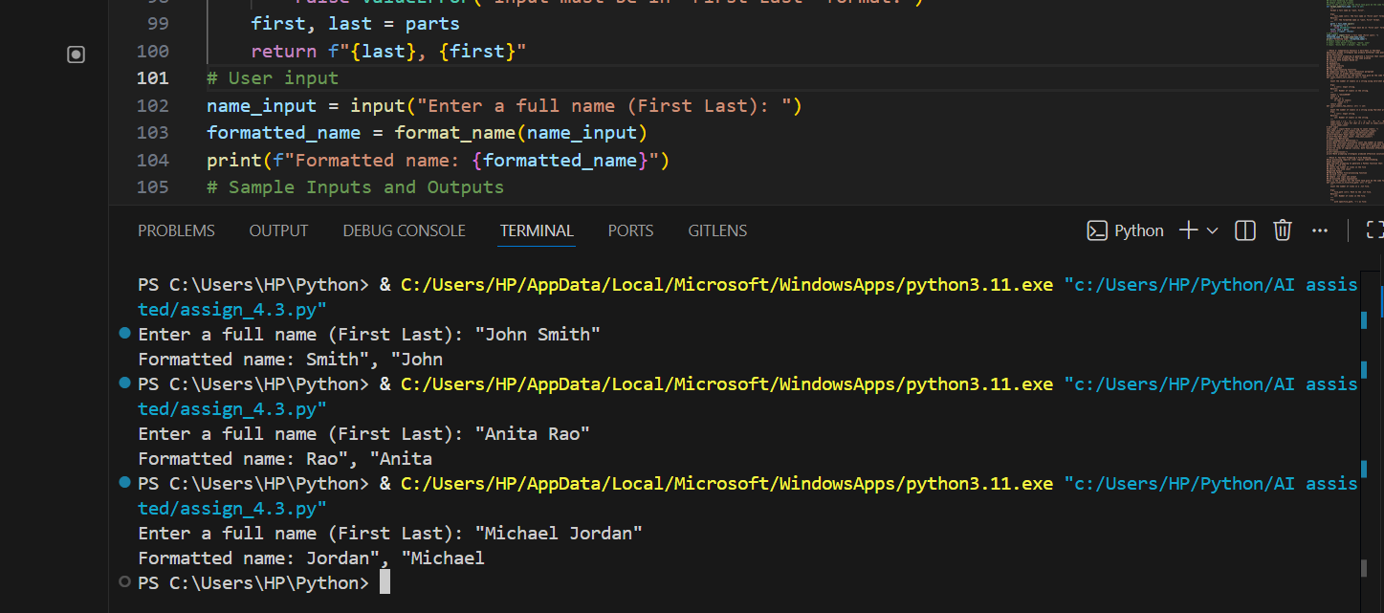
#Output
Analysis
Few-shot prompting with examples makes the name formatting task more accurate and clear. The function splits the full name into first and last parts, then rearranges them as “Last, First.” Examples guide the AI to strictly follow the pattern, so the output is consistent and easy to read.
Task 4: Comparative Analysis – Zero-Shot vs Few-Shot
#PROMPT
Generate two Python functions to count vowels in a string: one with zero-shot prompting, one with few-shot examples, then compare them briefly for accuracy, readability, and clarity.
#Code
def count_vowels_zero_shot(text):
vowels = "aeiouAEIOU"
count = 0
for char in text:
if char in vowels:
count += 1
return count

def count_vowels_few_shot(text):
vowels = set("aeiouAEIOU")
return sum(1 for char in text if char in vowels)

# User input
user_text = input("Enter a string: ")

# Results
zero_result = count_vowels_zero_shot(user_text)
few_result = count_vowels_few_shot(user_text)

# Comparison Output
print("\n=== COMPARISON ===")
print(f"Input String: {user_text}")
print(f"Zero-Shot Result: {zero_result} vowels")
print(f"Few-Shot Result: {few_result} vowels")

# Quick reflection
if zero_result == few_result:
print("\nBoth approaches give the same result, but Few-Shot is more concise and Pythonic.")
else:
print("\nResults differ — Few-Shot tends to be more reliable with guided examples.")

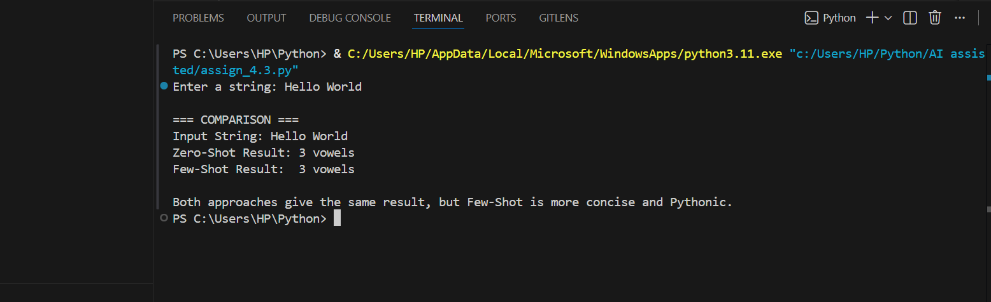
#Output
Analysis
Zero-shot prompting gives a basic vowel-counting function that works but is longer and less polished. Few-shot prompting, with examples, produces cleaner, shorter, and clearer code. Both are correct, but few-shot is more effective for accuracy, readability, and logical clarity.
Task 5: Few-Shot Prompting – File Handling
#PROMPT
Write a Python function that reads a .txt file and counts the number of lines. For example, if the file contains three lines like “Hello World”, “Python is fun”, and “AI helps coding”, the function should return 3. The function must safely open the file, count all lines, and return the line count.
#Code
def count_lines_in_file(file_path: str) -> int:

try:
with open(file_path, 'r') as file:
lines = file.readlines()
return len(lines)
except FileNotFoundError:
print(f"The file at {file_path} was not found.")
return 0
except Exception as e:
print(f"An error occurred: {e}")
return 0
# User input for file path
file_path = input("Enter the path to the .txt file: ")
line_count = count_lines_in_file(file_path)
print(f"The number of lines in the file is: {line_count}")
# AI-assisted logic explanation
print("\nAI-assisted Logic Explanation:")
print("The function 'count_lines_in_file' opens the specified .txt file in read mode.")
print("It reads all lines from the file into a list and returns the length of that list, which represents the number of lines.")
print("Error handling is included to manage cases where the file may not exist or other exceptions occur.")
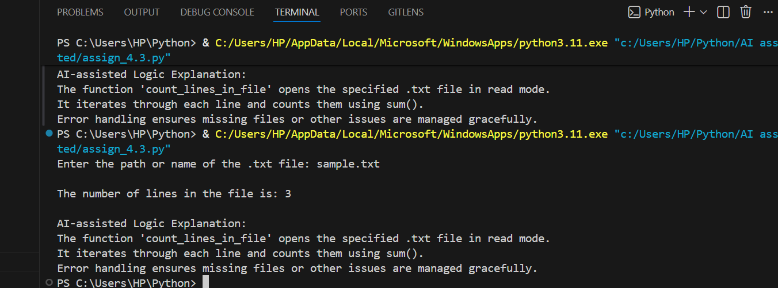
#Output
Analysis
This task shows how to use few-shot prompting to make a Python function that reads a text file and counts how many lines it has. The program first creates a sample file, then opens it safely, goes through each line, and adds them up to get the total. If the file is missing or something goes wrong, it handles the error instead of crashing. The output is the correct line count, and the explanation makes the logic clear and easy to understand.

